

GOVERNMENT OF INDIA

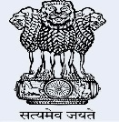

[This Photo](https://sanosanorequetesano.blogspot.com/2013/12/) by Unknown Author is licensed under [CC BY-NC-ND](https://creativecommons.org/licenses/by-nc-nd/3.0/)

Name - Sejal

DOB - 21 / 11 / 2004

Sex - Female

1234 5678 1234 5678